**Report on collected data Moul-Beesley Psychopathy/Attention studies**

**Exp 1 – data collected May to July 2014 (N = 54)**

Two stages. Simple test

CU traits median: 21

Outcome display duration:~3s

Results: (Blue=low CU). Nothing particularly exciting going on with median CU split

But it looks like they may be starting to diverge at around block 9.

**Exp 2 - data collected Oct 2014 to March 2015 (N = 60)**

Two stages

Participants: male

CU traits median: 23

Outcome display duration: ~3s

Results: No effect of CU split. (I think I remember that there looked like something was happening when split with the Levenson – hence adding the third stage)

**Exp 3 – data collected May to June 2016 (N = 47)**

Added third stage

Participants: male and female

CU traits median: 22

**Outcome display duration: ~1s**

Results: original graph of attention differences between high and low CU (included in ARC grant) (Blue=low CU)

**Exp 4 - data collected Oct 2016 to March 2017 (N = 27)**

Run at Uni of Sydney with children aged between 4 and 12

Participants: male and female

CU traits median: 17

Outcome display duration: ~3s

**Exp 5 - data collected Feb 2017 to May 2017 (N = 50)**

Coded questionnaires – Q data stored in Matlab files

Attempted replication of Exp 3.

Participants: male and female

CU traits median: 20

Outcome display duration: ~3s

Results: No replication (Blue=low CU). No replication effect when limited to first 1s either as far as I can tell. Due to low levels of CU??

**Exp 6 – data collected May 2017**

Zoe’s honours project

Three conditions:

**Condition 1 (100s) AGP, standard procedure (N=54)**

Participants: male and female

CU traits median: 23

Outcome display duration: ~3s

Results: Similar effect found as for exp 3 (NB excluding 6 ppts who didn’t learn – score>1 on B6)

Effect appears stronger when limited to the first 1s of outcome display. Potential replication of exp 3 results.

And similar when limited to first 0.5s of outcome display.

**Condition 2 (200s) AGP, with outcomes adjacent to responses (N=54)**

Participants: male and female

CU traits median: 21

Outcome display duration: ~3s

Results: Appear similar to results for exp 6.1

I plan to run 1s analysis on exp 6.2 data to see if the pattern follows the 6.1 data.

**Condition 3 (300s) bags and marbles (non social) with distal outcomes.**

Not yet analysed

**Further investigation:**

Q1. Given the results from exp. 3 in which the outcome was accidentally displayed for only ~1s – is an attention effect of CU only apparent in early stages of visual processing?

* This would fit with the literature regarding emotion recognition and conditioned-fear which demonstrates that top-down instruction appears sufficient to overcome the deficits.

Q2. Given that differences in attentional processing only start to appear from the second phase of the experiment – at which point the participant should realise that the outcomes are themselves predictive – is this an influence of associative learning on attention?

Q3. If the differences in attention are limited to the first few hundred milliseconds of outcome display – would this indicate CU-related differences in the influence of predictiveness (relevance) on automatic attentional capture? (I read your and Mike’s Psych Bulletin paper)

A1. My PhD student/RA ran a few extra analyses for me. The results below are just from experiment 6.1.

Figure1 below is (I think) what you suggested – mean time to first look to outcome by CU traits. It was a bit confusing over 18 blocks so we binned it into 9 blocks instead. So, in the graph below, blocks 1-3 = stage 1, 4-6 = stage 2, 7-9 = stage 3.

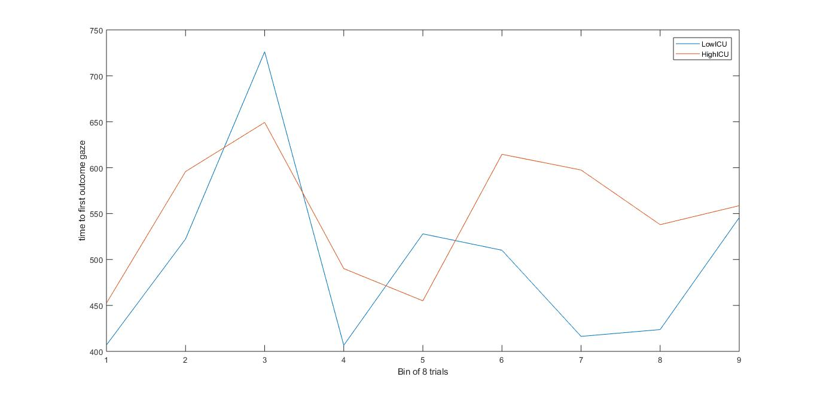

I would be interested to know a slightly different statistic – what proportion of participants from each CU group look to the outcome within e.g. 350ms?

In addition, he made these very pretty graphs.

This shows the average of the sum of 333millisecond bins across the duration of the outcome presentation. To make things simpler, graph 1 is blocks 1 and 2, graph 2 is blocks 3 and 4, graph 3 is blocks 5 and 6… and so on. So, each stage is in a separate row.

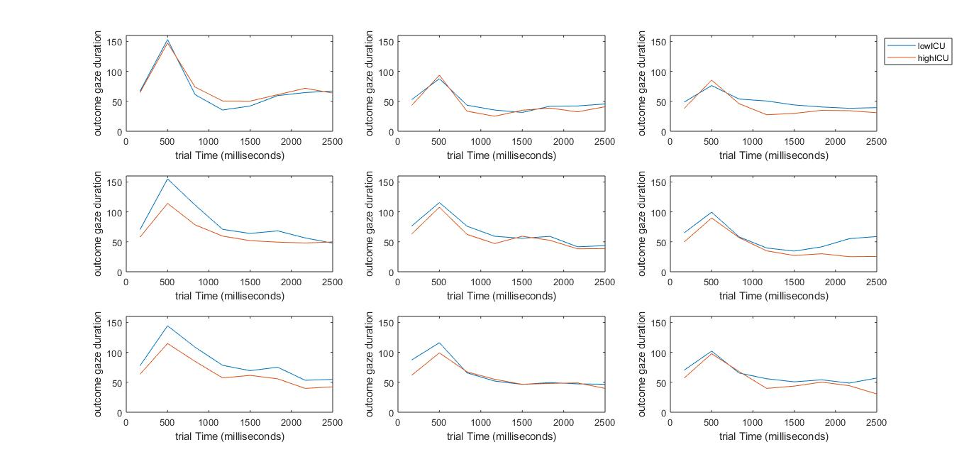

We think the increase in gaze duration at the end of the outcome presentation at the end of stages 2 and 3 (graphs 6 and 9) may be due to the instruction that precedes it which tells participants that they only have to get the presents right one more time. (The high CU group doesn’t appear to be influenced by that information very much!).